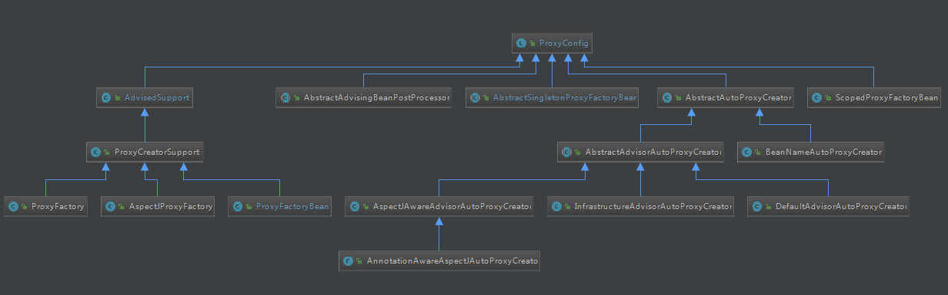

ProxyConfig

AdvisedSupport

ProxyCreatorSupport

ProxyFactory

AspectJProxyFactory

ProxyFactoryBean

AbstractAdvisingBeanPostProcessor

AbstractSingletonProxyFactoryBean

AbstractAutoProxyCreator

AbstractAdvisorAutoProxyCreator

AspectJAwareAdvisorAutoProxyCreator

AnnotationAwareAspectJAutoProxyCreator

InfrastructureAdvisorAutoProxyCreator

DefaultAdvisorAutoProxyCreator

BeanNameAutoProxyCreator

ScopedProxyFactoryBean

